
phgy311
lecture #: | date: | professor:
26 | Nov. 15, 2006 | Dr. Farookhi
27 | Nov. 17, 2006 | Dr. Farookhi
announcements:
- Good luck on the quiz!

Edited By: Steph Rolin
Do Not Redistribute
set #9
PHGY 311 – Lecture 26 November 15, 2006
Writer: Aradhana Persad Dr. Farookhi

Sample Quiz Question:

Question:
The graph demonstrates results from experiments conducted with ovarian granulosa cells. The cells were obtained from mature rats and cultured from 0 to 72 hours. The cells were cultured in either the culture medium alone, 1µg/mL PRL (prolactin), 300 ng/mL FSH or PRL+FSH (at same concentrations, respectively). At the 24, 48 and 72 hour time intervals the culture received 1β3PH-testosterone. Two hours later, the cultures were harvested and the amount of ³H₂O generated was evaluated. The amount of ³H₂O generated represents aromatase activity. Aromatase is a steroidogenic enzyme responsible for converting androgens into estrogen.
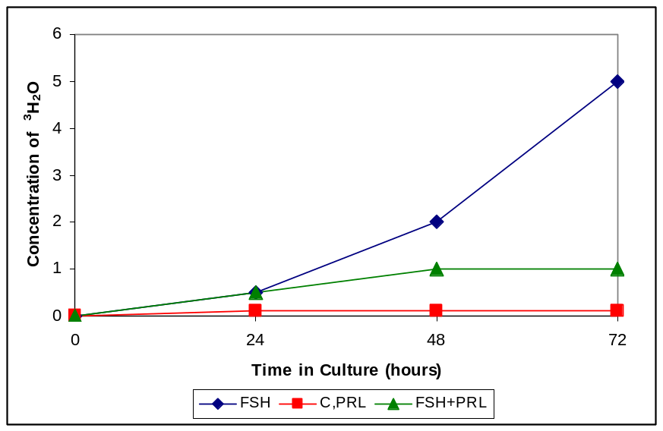
Note: The first thing you should do when given a graph is look at the axes and identify what the graph represents.

- In this case, the graph shows a time course for the production of ³H₂O, due to PRL, FSH or PRL+FSH, with respect to time.
- The y-axis represents production of ³H₂O, which is a surrogate for estrogen production, in response to the varying stimuli (PRL, FSH).
  - In other words, since ³H₂O represents aromatase activity and aromatase produces estrogen, ³H₂O also represents estrogen production.
- The culture medium and PRL (C, PRL on the graph) were used as controls for this experiment. ³H isotopes were used to label the testosterone and follow its breakdown by aromatase.

Question 1: What is the effect of FSH on aromatase? Is it altered by prolactin?

- From the graph, when FSH was added to the culture the concentration of ³H₂O increased. Therefore, FSH causes an increase in aromatase activity
- Also from the graph, when PRL was added in with the FSH, the concentration of ³H₂O present was altered. This indicates that PRL does have an effect on FSH.
Question 2: Which specific signaling pathways are interacting in the FSH+PRL culture?

- To determine which specific pathways are interacting, you must first identify the family each hormone belongs to, in order to identify which receptor family and signaling pathway they belong to.
- FSH is a glycoprotein produced by the anterior pituitary gland. Glycoproteins transduce signals via G-protein linked cell surface receptors. The binding of glycoproteins activates a G-protein cascade, which leads to the production of cAMP.
- Prolactin is a peptide protein, belonging to the same family as growth hormones (GH). PRL and GH bind to a family of receptors known as cytokines. These cytokinase receptors signal via the Jak-Stat pathway.
- Therefore, the G-protein coupled and Jak-Stat signaling pathways much be interacting together to produce this effect

Question 3: What is the most likely explanation for prolactin having no effect on aromatase activity on its own, but also causing the lowered effect of FSH on the cell?

- From the graph, the FSH+PRL culture produces less ³H₂O than the FSH culture does on its own. Therefore, it is clear that PRL is having an inhibitory effect on FSH, since it has no effect on its own.
- But why is there no difference between FSH and FSH+PRL before 24 hours? Why is it only inhibitory at 48 and 72 hours and why is there no change between these two time intervals?
  - For the simplest reasoning, in order for a hormone to react you need a receptor. In this case, FSH stimulates the formation of PRL receptors. Prior to 24 hours, prolactin receptors have not yet been formed, since it takes time for FSH to signal their formation.
- Therefore, to answer the question, PRL has no effect on in the first 24 hours because it needs FSH to stimulate the production and insertion of its receptors into the membrane.

Note: This question is looking for the simplest reason. However, other explanations may be valid, if your reasoning is well explained and takes into account all of the results seen in the experimental data.

Glycoproteins
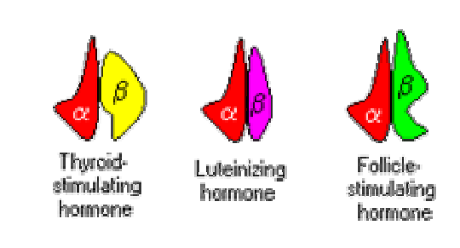
- Glycoproteins produced in the anterior pituitary include thyroid-stimulating hormone (TSH), follicle-stimulating hormone (FSH) and luteinizing hormone (LH)
- Glycoproteins are composed of two subunits
  - The α-subunit is common to all 3 glycoproteins
    - Necessary to activate receptors.
  - The β-subunit is distinct in each hormone.
    - Provides specificity
- This demonstrates that an α-β dimmer is needed for the biological activation of glycoprotein receptors.

Adrenocorticotropic Hormone (ACTH)
- ACTH, also known as corticotrophin, is produced in the anterior pituitary. It is not made for subunits as it is derived from a prohormone.

- ACTH comes from a classic prohormone, pro-opiomelanocortin (POMC)
  - In the anterior pituitary, the secretory vesicles of POMC will be processed to become ACTH
  - Below, ACTH is shown to be only a small part of POMC
    - Proteases will splice at the Lys-Arg sequences flanking both sides of the gene, resulting in ACTH
- If POMC is spliced in the intermediate pituitary, the prohormone will be spliced into different hormones
  - In this case, the ACTH sequence is further spliced to produce α-MSH and CLIP
  - β-LPH is spliced again to form γ-LPH and β-Endorphin

- This shows that the enzymes located in the two lobes of the anterior pituitary are different, resulting in the different hormones being produced.
  - In this case, PCI, a Lys-Arg protease, was found in the anterior pituitary
  - PCII was found in the intermediate pituitary

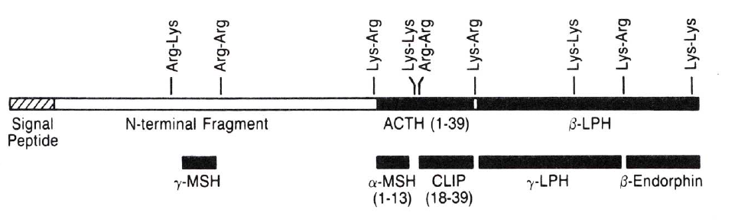
Take Home Message:
The same prohormone, POMC for example, can be processed in various ways to produce different hormones, depending on its location in the pituitary gland, or other endocrine glands, since these contain different processing enzymes.

Periodic and Pulsatile Release of Hormones
- Hormones of the hypothalamus and pituitary are released periodically in a pulsatile manner
  - Pulsation refers to a hormone being released in small doses over a period of time, instead of being released in a high dose continuously.

- Some hormones follow a circadium rhythm, meaning that their levels are regulated to follow a 24 hour daily pattern.
  - A circadium rhythm is an example of periodicity, the increase and decrease in hormone levels over time

- Below is a graph showing the changes in plasma ACTH levels and plasma 11-OHCS (11-hydroxy corticosteroid) levels, as a function of time, over a 24-hour period
- For both hormones, periodicity is seen in this graph
  - They show a significant increase in the mornings due to arousal, which then falls to lower levels throughout the day, with occasional increases, depending on the time of day
  - Therefore, the graph shows a circadian rhythm, since it follows a 24-hour period.

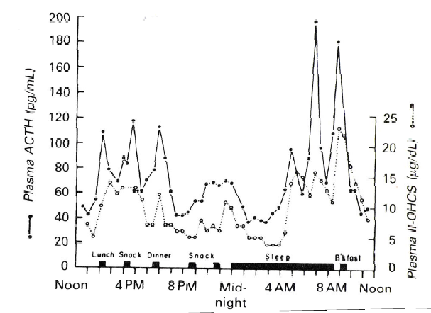
- At each location marked with the intake of food, the concentrations of both plasma hormones increases.
  - This indicates that eating food affects the concentrations of these hormones.
- Glucocorticoids are involved with glucose metabolism, as well as immune system regulation, protein metabolism, etc
  - Therefore, it makes sense that food intake will increase the concentration of ACTH and 11-OHCS, since they are both glucocorticoids involved in glucose metabolism

LH Periodicity
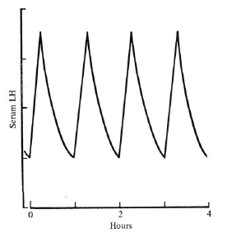
- The graph to the left shows the serum concentration of LH as a function of time in ovariectomized female rats
  - Since these rats do not have ovaries, there is no negative feedback on LH production by estrogen. Elevated serum levels of LH are seen in these rats compared to normal rats

- Although the overall concentration of LH is elevated, from the graph it is shown that LH is still being released in a pulsatile matter.
  - In other words, LH is not elevated due to a constant and continuous release

- LH release from the pituitary gland is dependent on GnRH (gonadal releasing hormone) release from the hypothalamus
  - This infers that the release of GnRH must be pulsating as well, to cause the pulsatile release of LH
    - If GnRH is mapped, it follows almost exactly the same pulsatile pattern as LH, except it is shifted slightly to the left since its release precedes LH release

- From the graph, the pulse frequency of LH is approximately 1 pulse/hour. Based on this frequency, the LH t_{1/2} (the half life of LH) is approximately 30 minutes.
- In conclusion, since we have a GNRH and LH pulsating release, we must have a pulse generator in the hypothalamus.
  - This was in fact found in this female rat.
  - Males also have a pulse generator. If they are gonadectomized, they will also show pulsatile LH release.

Note: This pulse generator in females has some interesting feedback mechanisms, which will be looked at in the reproductive section

LH Pulse is Affected by External Stimuli
- The graph below is from an experiment, showing the changes in a male rat’s serum LH levels over time, in response to varying exposures to female rats.
  - For the first exposure to the female rat, the male’s LH levels increase dramatically, indicating his interest in the female
  - The second time the same female rat is placed in the cage, the LH response has decreased slightly
  - On the third exposure to the same female, there is an insignificant LH response in the male, indicating he now has little to no interest in this female.
- For the last exposure, a different female rat was used and once again a significant increase in LH levels was seen, indicating the male’s interest in this new female.
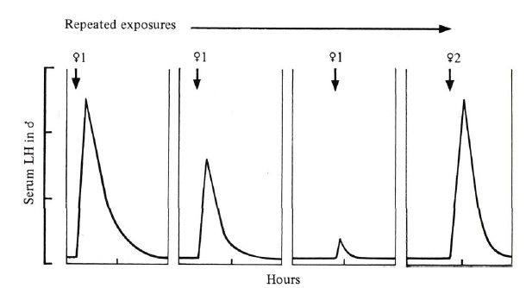
Take Home Message:
This experiment shows that changing an external stimulus can regulate the pulsatility of hormonal release, and as a result regulate the overall serum concentration of the hormone, which in this case was LH.

The Posterior Pituitary
- The posterior pituitary gland is an out-pocketing of the brain and consists of neural tissue
- It produces two major hormones: Oxytocin and Vasopressin
  - Both of these hormones are synthesized from prohormones
  - They are synthesized in the hypothalamic nuclei and released at the axon terminals located in the posterior pituitary, via secretory vesicles.

- Below is the prohormone of vasopressin.
  - Processing of this prohormone occurs in the secretory vesicles
  - Neurophysin A has an unknown function
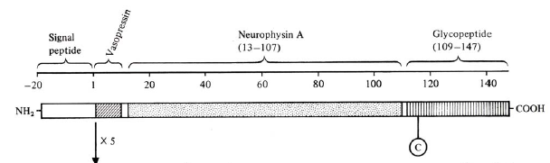
    - It was argued it was a vasopressin transporter molecule, but this hypothesis has been proven wrong
- Oxytocin has a similar prohormone, with its own neurophysin, and it is processed in the same way
Vasopressin
- Vasopressin is also known as anti-diuretic hormone (ADH)
  - It acts to increase water retention and as a result also increase blood pressure
- Its release is triggered by osmoreceptors, which sense changes in osmolarity
  - These osmoreceptors are located in the brain, possibly in the paraventricular nuclei (PVN) or supraoptic nuclei (SON), near the site of vasopressin synthesis and release.
    - This allows them to have a direct and fast response on hormonal release
  - They are not located in the kidneys!

- The normal resting plasma osmolarity is approximately 280 mOsm/kg
  - If there is an increase in plasma osmolarity, it triggers the secretion of vasopressin
  - This causes an increase in urine osmolarity and results in your kidneys up-taking water back from your urine
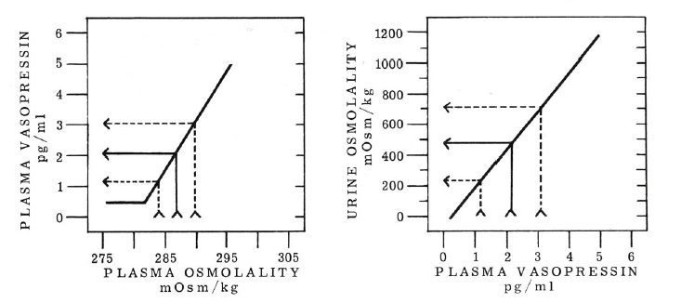
- The graph on the right shows that an increase in plasma osmolarity, above its normal resting value, is directly due to the increase in plasma vasopressin.
- The graph on the left indicates that as plasma vasopressin increases, urine osmolarity increases, since you are removing water from the urine.

- Vasopressin has two actions:
  - Vasopressive action on smooth muscle cells
    - This causes vasoconstriction which is stimulated via DAG activation, leading to IP3 production
    - Therefore, vasopressin acts on the G-protein coupled receptors of smooth muscle cells

  - ADH (water retention) action on the collecting tubules of the kidneys
    - This occurs via cAMP stimulation, causing the induction of aquaporins into the collecting ducts via mobilization to the intracellular side of the ducts
    - The activation of cAMP also occurs through G-protein coupled receptors

Take Home Message: This is an example of the same hormone acting on two different cell types, giving rise to the activation of two separate pathways, through a G-protein coupled receptor. This shows cell-contact specificity of a hormone binding to its receptor.

Stimuli Affecting Vasopressin Release
- Alcohol suppresses vasopressin release.
  - When you drink, water is flushed out into the urine and vasopressin action is blocked, preventing the re-uptake of water.
  - This causes dehydration
- The most dominant physiological stimuli for vasopressin release is the decrease in extracellular fluid volume
  - This affects the osmolarity, which in turn stimulates the osmoreceptors, to cause an increase in vasopressin release

Note: There are many stimulants that increase or suppress vasopressin release. These are just two examples that were mentioned in class. Be sure to look at the table in our notes for other examples. (Table 14.3)

Oxytocin
- Oxytocin targets mammary gland and uterus
- Secretion is stimulated by reflex arcs
- It acts on smooth muscles in the uterus and mammary glands to cause contraction
  - This contraction is due to the activation of G-protein coupled receptors which act on IP3
- It can be affected by steroid hormones
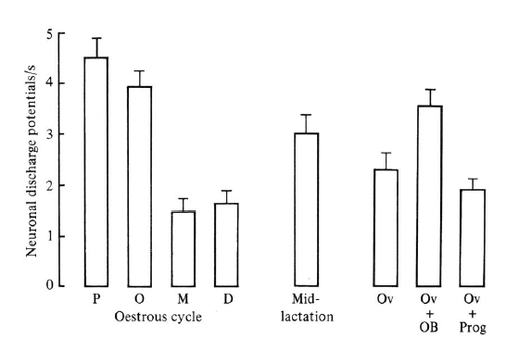
  - Hormones do not act independently. There exists interaction between the various hormones, leading to modulations of their effectiveness.

Oestrous Cycle of a Rat
- Below is the menstrual cycle of a female rat
  - Proestrous (P) is the day that the rat ovulates
  - Oestrous (O) is the day that the rat will allow the males to mate with her
    - Oestrous mean heat
    - She will not allow the male near her during any other time
  - Metestrous (M)
  - Diestrous (D)
- At the beginning of the cycle (proestrous and oestrous), during the follicular development, there is an increase in oxytocin release.
  - Developing follicles release estrogen, therefore this data suggests that estrogen is involved in stimulating oxytocin release
- To test the effects of estrogen on oxytocin, the animal was ovariectomized (Ov)
  - When given doses of estrogen, the amount of oxytocin produced once again increased (Ov + OB)
  - The rat was also given progesterone (Ov + Prog) and this showed a slight decrease in oxytocin production
    - It was therefore concluded that estrogen stimulates oxytocin production.

PHGY 311 – Lecture 27 November 17, 2006
Writer: Steph Rolin Dr. Farookhi

JOST PARADIGM
Chromosomal Sex

Gonadal Sex

Phenotypic Sex

- Chromosomal sex determines male versus female.
  - This is the key to sex determination.
- After chromosomal sex has been determined, gonadal sex becomes apparent as gonads differentiate appropriate to chromosomal sex.
- Phenotypic sex is established after gonadal sex. It is the appearance of tissues particular to one sex and establishment of certain changes in the CNS.

CHROMOSOMAL SEX
- Chromosomal sex is determined by the sperm.
  - Females can only donate an X-chromosome, whereas males have either an X- or a Y-chromosome to donate.
- Fertilization occurs when the oocyte and sperm combine to form a zygote.
  - The oocyte is diploid until ovulation. It contains an X-chromosome.
  - The sperm is haploid and contains either an X- or a Y-chromosome.

- Certain abnormalities can occur:
  - The female oocyte is diploid and arrested in meiosis before ovulation. If it separates improperly and has abnormal meiosis, it can either be O or XX instead of containing only a single X.
- If an O combines with an X-sperm, the result is XO.
  - This case is known as gonadal dysgenesis. This individual will be female; however she will have no ovaries. In order for the ovaries to form, there must be 2 X’s present.
  - The only place XX is needed is to form the ovary. Usually, one of the two X’s is inactivated, so this individual will be a normal female, except without ovaries.

- If an XX combines with an X-sperm, the individual is XXX, or a superfemale.
  - There is nothing wrong with these individuals. They are females with 2 inactivated X’s, instead of 1.

- If an O combines with a Y-sperm, the mutation (YO) is lethal.
  - The X-chromosome is necessary for life.

- If an XX combines with a Y-sperm, the resultant individual is male (XXY) and has seminiferous tubules dysgenesis.
  - There is a problem with the development of the tests and establishment of the gametes.
  - Males don’t inactivate X’s, as they typically don’t need to. The additional X leads to problems in development.

GONADAL SEX
- Once chromosomal sex is established, then gonadal sex differentiates.
  - We are assuming everything is normal: either XX or XY.
- The default pathway for accessory sex tissues is female.
  - In order to become male, something must occur. In the absence of a stimulus, the gonads become female by default.
- The deciding factor for male is the presence of SRY, the sex determining region of Y-chromosome. SRY is the testis determining factor (TDF).
  - If a zygote expresses SRY, the gonad becomes a testis.

- Sometimes, in individuals with abnormal recombinations, the SRY is transferred to the X-chromosome.
  - The individual in which this occurs is a perfectly normal male. It does not matter whether the X- or the Y-chromosome is expressing SRY, only that it is being expressed.
- However, if this individual has offspring, their offspring may encounter problems.
  - If the male parent (the one with the SRY on the X-chromosome) donates an X, the zygote is XX, but expressing SRY.
    - XX-Male
  - If the male parent donates a Y, the zygote is XY, but lacks SRY.
    - XY-Female.
- The point is that SRY determines everything. It doesn’t matter which chromosome SRY is on, it only matters that it’s present.

CHROMOSOMAL DISORDERS
- Gonadal dysgenesis
  - XO and variants
- “Superfemales”
  - XXX
- Seminiferous tubule dysgenesis
  - XXY
- True hermaphroditism
  - True hermaphroditism occurs when there are both ovaries and testes. This does not happen in humans.

DEVELOPMENT OF GONADAL SEX
- Jost performed several experiments investigating the factors influencing gonadal sex and phenotypic sex development.
  - Removed gonadal ridge in rabbit embryos, and genotypic males were born as females.
  - If he removed the gonadal ridges and inserted testosterone pellets, the rabbits were phenotypic males with residual female internal genitalia.

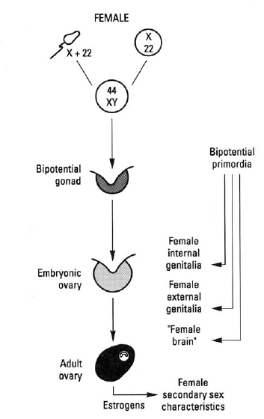
- The gonad is bipotential—it can become either male or female.
  - Becomes male if SRY is expressed. SRY causes differentiation, forming embryonic testes.
  - In the female, nothing happens. The gonads automatically become ovaries.
    - This takes more time and is slower than male development.

- There are 2 ducts, the Mullerian duct and the Wolffian duct.
  - In the absence of anything, the Mullerian duct becomes the fallopian tubes, ovaries, uterus, and 1/3 of the vagina.
    - This is the default pathway.
  - The Wolffian duct automatically degenerates.
- This is what occurs in the female.
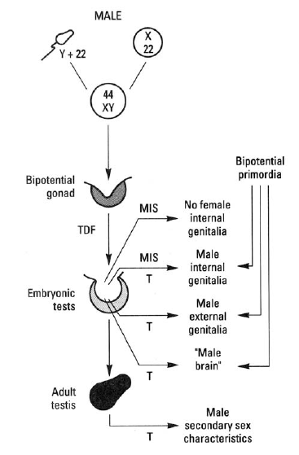
- The male needs to develop faster than the female, in order to prevent the above from occurring. As soon as the testes are formed, they begin secreting hormones. The most important are Mullerian inhibitory substance (MIS) and testosterone.
  - Without these, there is trouble forming the internal and external genitalia.

- MIS is responsible for the development of internal genitalia.
  - MIS is a member of the TGF-Beta Family. Think about what this means, as far as its signaling pathway.
- MIS causes degeneration of the Mullerian duct, the precursor for internal female genitalia. This leaves the Wolffian duct.
- The androgens produced by the testes will maintain the Wolffian duct and allow for its subsequent differentiation.
- External genitalia development requires androgens, specifically dihydrotestosterone (DHT), a potent testosterone.
  - Recall: testosterone is formed from cholesterol, which is transformed to pregnenolone in the mitochondria.
  - Eventually, it can become testosterone, which may be converted to estradiol.
- In the presence of aromatase enzyme, testosterone can become estradiol.
  - t-aromatizable enzyme.
- However, what happens during development is that DHT is formed from testosterone, in response to the presence of 5-alpha-reductase.
  - DHT cannot be converted to estradiol. It acts on androgen receptors.
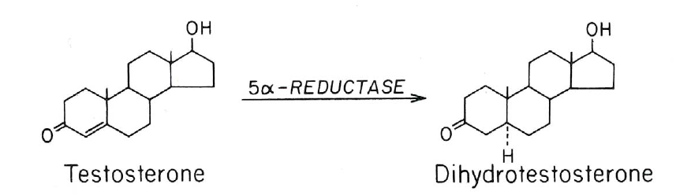
- DHT is required during embryonic development in order to fully differentiate. Some people lack 5-alpha-reductase, and as a result, they have ambiguous external genitalia at birth.
  - At puberty, virilization (taking on male characteristics) occurs. This happens in response to an abrupt increase in testosterone production. Based purely on concentration, there is now enough testosterone to act on the androgen receptor and stimulate external genitalia.

DISSOCIATION CONSTANT
- Androgen receptors bind DHT with a greater affinity.
  - This means that there is a smaller dissociation constant, KD.
KD = [Hormone] * [Receptor]
[Hormone bound to Receptor]

- There is 50% binding at KD. So, if the dissociation constant is smaller, then at a smaller concentration, 50% of receptors will be bound to hormones.
  - If substance A has a KD of 10E-10M, then at 10E-10M, 50% of the receptors will be bound. This receptor has great affinity for substance A than substance B, which has a KD of 10E-5M.
    - The receptor binds substance A with a greater affinity.

